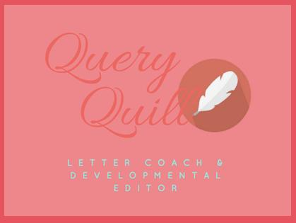

MM Finck (“Peggy”)
mmfinck.com/queryquill
queryquill@gmail.com

TROPE TALK: How to Use - and Not Use - Tropes
HANDOUT

1. WHAT IS A TROPE?

2. IS A CLICHE A TROPE? IS A TROPE A CLICHE?

3. TYPES OF TROPES

4. “I’M VERY CREATIVE, AND I DON’T WANT TO CHEAT. I’M GOING TO WRITE MY STORY WITHOUT ANY TROPES.”

5. ARE ALL TROPES GOOD? (and a few words about subject matter)

6. BACK TO TROPES

7. HOW CAN I USE TROPES WELL?

QUESTIONS?

(Questions about querying or publishing welcomed, if time.)

