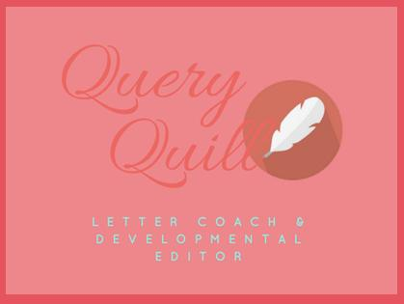

MM Finck (“Peggy”)
mmfinck.com/queryquill
queryquill@gmail.com

I Wrote It. Now What Did I Write? And What Now?
HANDOUT

GENRES - ie, subject matter
- Action
- Adventure
- Bildungsroman
- Comedy
- Crime and Mystery
- Fantasy, including magical realism
- Graphic Novel
- Historical Fiction
- Horror
- Literary Fiction
- Memoire
- Non-fiction, including food and drink, art and photography, historical, self-help, true crime, etc.
- Poetry
- Romance
- Satire
- Science Fiction
- Short Story
- Speculative, including dystopian
- Thriller
- Western
- Other, including combinations

(Some) CATEGORIES - ie, audience
- Board and picture books
- Children’s
- Middle Grade
- Young Adult
- Women’s Fiction
- LGBTQIA+/LGBTQ+
- Literary Fiction - the only one that is typically viewed as both a genre and category
- Upmarket Fiction
- All the categories of non-fiction

HALLMARKS AND CONVENTIONS

WORD COUNTS

FINDING AGENTS WHO WANT WHAT YOU WROTE

