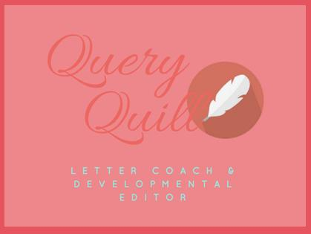

MM Finck (“Peggy”)
mmfinck.com/queryquill
queryquill@gmail.com

MASTER CLASS: How to Perfect Your Query
HANDOUT

QUERY LETTER COMPONENTS
- Genre
- Comps
- Word Count
- Opening line
- Story question
- Character
- Obstacles
- Stakes
- Ticking Clock
- Climax
- Voice
- Theme
- Personalize
- Bio
- Other

AGENTS
- How to find
- How to personalize

EXAMPLES OF STRONG QUERIES

ANALYSIS OF PRE-CRITIQUED PARTICIPANT QUERIES

IN REAL TIME QUERY FEEDBACK

